Nanopore sequencing provides superior *MGMT* promoter methylation evaluation compared to conventional techniques

Skarphedinn Halldorsson *1, Richard Nagymihaly1, Areeba Patel2, Petter Brandal3,

Ioannis Panagopoulos3, Henning Leske4, Felix Sahm 2, and Einar O. Vik-Mo†1

1Vilhelm Magnus Laboratory, Institute for Surgical Research, Oslo University Hospital

2Department of Neuropathology, University Hospital Heidelberg, Heidelberg, Germany

3Section for Cancer Cytogenetics, Institute for Cancer Genetics and Informatics, Oslo University Hospital

# Abstract

**Rationale:** Resistance of glioblastoma to the alkylating agent temozolomide may result from the expression of the DNA repair protein O6-methylguanine-DNA methyltransferase (MGMT). Methylation of the *MGMT* promoter region has been correlated with responsiveness to temozolomide, but there is no consensus on the most accurate method to determine this methylation. Conventional methods have limitations due to the dependence of bisulphate treatment and amplification. Nanopore long-read sequencing offers methylation analysis of native DNA without the need for these steps, potentially resulting in a more correct read. Combined with recent advancements in targeting methods, we evaluated if Nanopore sequencing provides an accurate, broader and more cost-effective approach to *MGMT* promoter methylation analysis.

**Methods:** We analyzed 148 CNS tumors using Nanopore sequencing and compared the results to data obtained using pyrosequencing or methylation bead arrays. We used Oxford Nanopore Technologies (ONT) MinION flow cells to run single or barcoded (multiplex) assays, following a CRISPR/Cas9 protocol, and included results from adaptive sequencing runs. We then compared the methylation data to results from standard diagnostic methods.

**Results:** We found a 92% correlation between pyrosequencing of 4 CpGs in the CpG island of *MGMT* and nanopore sequencing. We could re-create classification by the MGMT STP27 algorithm with data from nanopore sequencing. Furthermore, we were able to include in the analysis an additional 94 CpGs within the *MGMT* CpG island and 17 CpGs within the island shores. Data clustering revealed a robust difference between unmethylated and methylated samples that could be used for patient stratification.

**Discussion:** Our findings demonstrate that ONT is a capable method for replacing pyrosequencing, or methylation bead-array, providing high-confidence results within a few hours of sequencing. The extension of the analysis to all of the 98 CpGs of the CpG island of the *MGMT* promoter region results in a complete picture of the investigated *MGMT* region, which potentially enables further exploration of the correlation between methylation status and additional clinical parameters. However, for full replacement of standard diagnostic methods such as pyrosequencing analysis, further studies need to be performed using nanopore sequencing to refine the treatment relevant sites and cut-off levels for methylation.

**Keywords:** *MGMT* promoter methylation, Nanopore sequencing, CRISPR/Cas9, Glioblastoma

# Introduction

Glioblastoma multiforme (GBM) is the most common and most aggressive type of primary malignant brain tumor in adults [Ostrom et al., 2020] with a median survival of about 15 years [Stupp et al., 2017]. Standard treatment for GBM involves surgical resection of the tumor followed by a combination of radiation and chemotherapy. Temozolomide (TMZ) is a chemotherapy drug that has been shown to improve the outcome in a subset of GBM patients when used in combination with radiotherapy [Stupp et al., 2009]. It is an alkylating agent that induces DNA damage by methylation of O-6 guanidine residues in dividing cells, leading to DNA damage and apoptosis [Zhang et al., 2011]. Despite its potential benefits, TMZ can cause a range of side effects and should therefore be limited to patients that may benefit from it and withheld from patients that most likely will only experience the side effects without any improvement in survival.

The effects of TMZ are countered by the DNA repair protein O-6 methylguanine DNA methyltransferase (MGMT). MGMT expression is regulated via methylation of the promoter region [Nakagawachi et al., 2003]. The presence of *MGMT* promoter methylation has been associated with increased survival in glioblastoma patients treated with temozolomide and radiation therapy [Hegi et al., 2019]. Methylation of the *MGMT* promoter is believed to silence its expression, thereby increasing sensitivity of GBM tumor cells to TMZ. *MGMT* promoter methylation status is therefore an important factor for the management and treatment of GBM [Christmann et al., 2011].

Pyrosequencing is a commonly used method to detect *MGMT* promoter methylation in clinical samples. The Qiagen® MGMT pyrosequencing kit, which detects methylation on 4 CpG sites (76-79) on the *MGMT* promoter CpG island, is a common choice in the clinical setting. However, there is neither a clear consensus on the best cut-off point to classify clinically relevant methylated or unmethylated samples [Brandner et al., 2021], nor which method should be used.

Standard diagnostic techniques include methylation-specific PCR (MSP), pyrosequencing (PSQ) or methylation bead array [Johannessen et al., 2018]. All of these methods rely on bisulfite conversion of native tumor DNA prior to analysis and only include a fraction of the 98 potentially relevant CpG sites in the CpG island of *MGMT* (Nakagawachi et al., Malley et al 2011).

In recent years, advances in sequencing technology have allowed for more sensitive and accurate detection of DNA methylation. Nanopore sequencing, which uses a nanopore-based sensor to detect changes in electrical current as nucleic acids (DNA or RNA) pass through the pore, has the ability to detect epigenetic modifications, such as methylation, directly from the signal [Jain et al., 2016]. Due to the long-read nature of nanopore sequencing, it also affords methylation analysis of far longer sequences than either MSP or pyrosequencing. Consequently, nanopore sequencing offers an overview of the methylation status of all CpGs of the *MGMT* CpG-island including the promoter region, using native genomic DNA without bisulfite conversion, which can be both time and cost efficient in a clinical setting [Laver et al., 2015].

In this study, we compared the results of nanopore sequencing of the promoter region of *MGMT* of 148 central nervous system (CNS) tumors, including 91 GBMs, with results obtained from standard diagnostic methods comprising pyrosequencing or Illumina 850K bead array.

# Materials and Methods

## Patients and samples

Samples from three independent cohorts were included into this study; 1) Retrospective analysis of DNA from 68 CNS tumor samples provided by the Institute for Cancer Genetics and Informatics, Oslo University Hospital screened for *MGMT* promoter methylation using the Qiagen® MGMT pyrosequencing kit. 2) Retrospective analysis of 67 sequences generated as part of the *Rapid-CNS* adaptive sampling pipeline [Patel et al., 2022] analysed by Illumina® methylation 850K bead array. 3) DNA extracted from 16 glioma biopsies that were operated at Oslo University Hospital. A separate biopsy derived from paraffin-embedded tissue was analysed with the Qiagen® MGMT pyrosequencing kit at the Dept. of Molecular Pathology. Table 1 provides an overview of samples used in this study.

A total of 153 samples from 148 patients were analyzed for *MGMT* promoter methylation, consisting of 91 GBM samples, 23 IDH-glioma samples, and 12 meningioma samples (Figure 2a). Two methods were used to enrich for the region of interest: CRISPR/Cas9 targeted sequencing of the *MGMT* promoter region [Wongsurawat et al., 2020] and adaptive sampling. Cas9 targeted sequencing was applied to 86 samples, 46 of which were run as single samples and 40 that were run as multiplexed groups of five samples. 67 samples were analyzed as part of an adaptive sampling pipeline.

## Sample preparation and Nanopore sequencing

Between 10 and 25 mg of fresh/frozen tissue were used to extract genomic DNA (Merck’s GenElute™ Mammalian Genomic DNA Miniprep kit) following the manufacturer’s protocol. Purity and concentration of DNA samples was determined using NanoDrop™ One and Qubit™ 4 Fluorometers (Thermo Fischer Scientific). Isolated DNA was stored at -20°C until analysis. Cas9 mediated targeted sequencing was performed with the Cas9 Sequencing Kit (Oxford Nanopore Technologies) according to the manufacturers protocol (version ENR_9084_v109_revR_04Dec2018). Briefly, Cas9 ribonucleoprotein complexes (RNPs) were created by mixing equimolar concentrations (100 µM) of crispr RNA (crRNA) and trans-activating elements (tracrRNA) to HiFi® Cas9 enzyme (IDT). Dephosphorylated gDNA (2-5 µg) was cleaved and dA-tailed with Cas9 RNPs and Taq polymerase. Finally, sequencing adaptors were ligated to the cleaved fragments and the final DNA library was purified with AMPure XP beads (Beckman Coulter). Barcodes were applied to a number of samples to allow multiplexing of five samples based on an experimental protocol from Oxford Nanopore Technologies. Purified DNA libraries were loaded onto R9.4.1. flow cells on MinION Mk1B or Mk1C devices and sequenced for 4-24 hours. Individual flow cells were flushed and re-used up to four times for single samples and twice for multiplexed samples. A minimum pore-count of 300 was deemed sufficient for a single sample, 800 for multiplexed samples. Raw fast5 sequences of all fragments mapping to the *MGMT* promoter in the Rapid-CNS data were provided for re-analysis.

## Primers

All primers were purchased from Integrated DNA Technologies, IDT (Leuven, Belgium). Previously published primers were initially used to target the *MGMT* promoter [Wongsurawat et al., 2020], termed MGMT-left-1 (ATGAGGGGCCCACTAATTGA) and MGMT-right-1 (ACCTGAGTATAGCTCCGTAC), which yielded produced a fragment of 2,522 bp. In order to increase cas9 efficiency and expand the size of the fragment, we added additional crRNA primers: MGMT-left-2 (GCCAACCACGTTAGAGACAATGG), MGMT-right-2 (GTACGGAGCTATACTCAGGT), MGMT-right3 (CTGGAATCGCATTCCAGTAGTGG) and MGMT-right-4 (ACTTCGCAAGCATCACAGGTAGG) providing a fragment of 4,800 bp.

## Data analysis

Raw sequences were base-called, methylation called and mapped (hg19, chromosome 10) using the Megalodon toolbox (version 2.5.0 built on guppy version 6.2.7) from Oxford Nanopore Technologies (https://github.com/nanoporetech/megalodon). Methylation percentages of individual CpG sites were compiled using custom scripts in R. All statistical analyses were performed in R (version 4.2.1). The source code and data to reproduce all analyses and figures from this manuscript is available at https://github.com/SkabbiVML/MGMT_R.

# Results

**Data Acquisition**

Sequence depth of the *MGMT* promoter region in the samples varied based on method, sequencing time, DNA and flow-cell quality. Single sample runs produced on average more sequences (mean = 92.1, median = 33) than barcoded runs (mean = 17.2, median = 12) and adaptive sampling (mean = 18.7, median = 15) (Figure 2b). No bias in sequencing depth was observed between methylated and unmethylated samples across Cas9 targeted samples, either single or multiplexed. However, a slight but statistically significant difference in sequence depth was observed between methylated (mean = 23.6) and unmethylated (mean = 16.5) samples evaluated by adaptive sampling (p=0.021).

## Nanopore Sequencing versus Pyrosequencing

To allow for a direct comparison of the results of the MGMT pyro kit to the nanopore sequencing the methylation of CpGs 76-79 of the CpG island of *MGMT* gene was analyzed in 68 samples (Figure 3). The correlation between the methylation values of each overlapping CpG site between nanopore and pyrosequencing ranged from 0.78 to 0.88 (Figure 3a). However, the correlation increased to 0.92 when methylation values were averaged across the four CpG sites (Figure 3b).

We have previously established and published a cut-off valuer for the categorization of samples into groups of methylated-/non-ethylated samples of 10% for the Qiagen® MGMT pyrosequencing kit (Havåik et al., 2012). Using this cut-off, we found a 91% concordance rate between the two methods (62 out of 68 samples) (Figure 3c an d). Notably, discordant results between nanopore sequencing and the MGMT pyro kit were in all cases classified as methylated by nanopore sequencing but unmethylated by pyrosequencing.

Illumina® Human Methylation BeadChips (HM-27K, HM-450K, and HM-850K) are microarray-based platforms used to investigate DNA methylation patterns in human tumor samples. Despite detecting the methylation status of tens to hundreds of thousands of CpG sites, these platforms only cover a fraction of the approximately 30 million CpG sites in the human genome. To predict the clinically relevant methylation status of the *MGMT* promoter, a regression model called *MGMT STP-27* has been developed. This model uses the methylation status of two CpG sites, cg12434587 and cg12981137, as reported by Bady *et al.* [Bady et al., 2012, Bady et al., 2016]. Methylation values for the two CpG sites represented in the MGMT-STP27 algorithm were extracted from the nanopore data and plotted against each other (Figure 4a). A clear separation between methylated and unmethylated samples based on the methylation percentages of cg12434587 and cg12981137 (Figure 4a, right) was seen in the samples from the Rapid-CNS cohort. However, the samples from the Radium cohort, which were classified as methylated or unmethylated by pyrosequencing, did not show as clear a distinction of these methylation classes when using the STP27 logistic regression model (Figure 4a, left).

We therefore followed the approach by Siller *et. al,* who proposed a method for GBM patient stratification by counting the methylation of the 25 CpG sites of the second differentially methylated region (DMR2) in the CpG island of *MGMT* using Sanger bisulfite sequencing [Siller et al., 2021]. The results of nanopore sequencing were binarized by applying a methylation cut-off of 10% to each CpG site (≥ 10% methylation = methylated, < 10% methylation = unmethylated) and summarizing the counts in DMR2. Figure 4b shows a nearly complete separation of methylated and unmethylated samples at ≥ 15 methylated CpG sites.

## Unsupervised clustering of samples based on nanopore sequencing

Although classification by bisulfite sequencing methods can be recreated to a reasonable degree with nanopore sequencing data, this does not take advantage of other CpG sites within the designated *MGMT* promoter CpG island or its shelves that may prove to be relevant for MGMT gene expression. To investigate the impact of methylation at CpG sites not covered by previous methods, we performed hierarchical clustering of 98 CpG sites on the CpG island of *MGMT* and included 7 CpGs upstream and 11 CpGs downstream. Unsupervised hierarchical clustering using Ward’s method revealed two main clusters that largely correspond to the classification into methylated and unmethylated samples by pyrosequencing or methylation bead array (Figure 5).

Unmethylated samples exhibit low methylation levels throughout the CpG island, except for the first 5 CpG sites, which were mostly methylated. In contrast, methylated samples show a larger gradient of methylation, with higher levels towards either end of the CpG island. This is further supported by the average methylation percentage of each CpG site in methylated and unmethylated samples (Figure 6), which reveals the biggest differences in methylation occur in CpGs 9 through 14 and 71 through 90.

While five samples previously classified as methylated cluster with the otherwise unmethylated samples, one unmethylated sample clusters with methylated samples. This pattern of separation is also evident when unsupervised clustering is performed on GBM samples only (Figure 7). In addition to the robust separation of samples into clusters that largely correspond to the predetermined methylation status, k-means clustering showed separation of samples in the methylated cluster (Figure 8). Of the 22 samples that cluster with methylated samples, 9 samples fall within what can be described as ”very high methylation” cluster. The functional significance of these clusters remains to be determined.

## Survival Analysis

Since methylation status of the *MGMT* promoter is known to be a predictive factor for overall and progression-free survival of GBM patients receiving temozolomide [Dovek et al., 2019], we investigated whether clustering by nanopore sequencing was as effective as the MGMT-pyro kit or EPIC-array for survival prediction. We conducted cas9-targeted nanopore sequencing on 16 additional samples that were simultaneously analyzed by pyrosequencing. In total, we performed survival analysis on 25 primary IDH-wildtype GBM patients (11 females, mean age 58.4 years and 14 males, mean age 62.7 years) where biopsies were classified by both MGMT-pyro kit and cas9-targeted nanopore sequencing (Table 3).

As expected, Kaplan-Meier survival analysis of patients based on pyrosequencing showed a significantly longer overall survival in patients classified as ”Methylated” (Figure 9a, p=0.0078). Notably, when patients were classified according to unsupervised clustering by nanopore sequencing (Figure 9b), significantly longer survival was observed in ”cluster 2” patients (p=0.039

# Discussion

To the best of our knowledge, this is the first study to examine all 98 sites within the *MGMT* CpG island, along with it’s shores in multiple patient biopsies using nanopore sequencing.Our results suggest that nanopore sequencing of the *MGMT* promoter region, even at low sequencing depth, can recreate the results of pyrosequencing, bisulfite Sanger sequencing and Illumina 850K bead array. However, the accuracy of classification depends on the method and cut-offs used to generate the ground truth. Unsupervised clustering of samples based on methylation of all 98 CpG sites in the *MGMT* promoter indicates the presence of subgroups within both methylated and unmethylated samples of unknown clinical significance. Although the sample size is small, our results suggest that classifying patients via nanopore sequencing is equally reliable as classification with the MGMT-pyro kit.

MGMT promoter methylation by nanopore sequencing two main advantages over conventional techniques. First, nanopore sequencing can detect epigenetic modifications on native DNA, thereby circumventing the need for bisulfite treatment. This saves time and reduces the potential risk of bias introduced by bisulfite treatment that has been shown to underrepresent densely hydroxymethjylated (5hmC) regions [Huang et al 2010] . Secondly, the long-read nature of nanopore sequencing offers a complete overview of the MGMT promoter CpG island and can be extended in either direction to include the shores and shelves of the CpG island. MSP and

Again, what is the advantage of using nanopore sequencing compared to the currently used methods (native DNA, easy to use, full picture of methylome of *MGMT,* )

Are there disadvantages in the use of nanopore sequencing (DNA quality issue? Possible on FFPE material? What about the costs. Are the results robust (those 5 extra samples (153 samples from 148 tumors) did they show similar results?))

Do you already have some information on the outcome of those GBM patients of tumours from OUS?

Even though this is very interesting, one needs to be cautious to not put this in the spotlight, as the paper is not focused on GBM and outcome, as there is a mixture of several entities here. The key message of this paper is to show that the method is comparable to other methods in terms of the results, and gains the advantage that it reveals additional information and uses native DNA and thus circumventing additional pre-analytic steps that might be error prone.

).

We can conclude that nanopore sequencing of the *MGMT* promoter region performs as well or better than standard methods such as pyrosequencing. This is true for both cas9 targeted sequencing of the *MGMT* promoter and inclusion of the *MGMT* promoter into an adaptive sequencing panel. Distinct subgroups within both methylated and unmethylated samples are captured via nanopore sequencing, it will be very interesting to see if there is a difference in patient outcome between these clusters.

# Tables

Table 1: Summary of samples included in this study.

|  |  |  |  |  |
| --- | --- | --- | --- | --- |
|  | **DenStem** | **Radium** | **Rapid-CNS** | **Total** |
| Astrocytoma | 3 | 1 | 3 | **7** |
| Astrocytoma_HG | 0 | 4 | 4 | **8** |
| ATRT_SHH | 0 | 0 | 1 | **1** |
| CNS_Neuroblastoma | 0 | 1 | 0 | **1** |
| Ependymoma | 0 | 1 | 0 | **1** |
| Ganglioglioma | 0 | 1 | 0 | **1** |
| Glioblastoma | 13 | 29 | 49 | **91** |
| HPC | 0 | 1 | 0 | **1** |
| LGG_PA | 0 | 0 | 4 | **4** |
| Medulloblastoma | 0 | 2 | 0 | **2** |
| Meningioma | 0 | 12 | 0 | **12** |
| Metastasis | 0 | 7 | 0 | **7** |
| Oligodendroglioma | 0 | 2 | 6 | **8** |
| PCNSL | 0 | 2 | 0 | **2** |
| PXA | 0 | 2 | 0 | **2** |
| **Total** | **16** | **65** | **67** | **148** |

Table 2: Summary of reported optimal cut-offs for determining methylated versus unmethylated samples

11

|  |  |  |  |  |  |  |  |  |
| --- | --- | --- | --- | --- | --- | --- | --- | --- |
| Author Year Method Patients CpGs Optimal cut-off Comment Reference | | | | | | | | |
| Hegi | 2019 | qMSP | 4041 |  | >1.27 | ”Grey-zone” patients benefit from TMZ | [Hegi et al., 2019] |
| Johannessen | 2018 | qMSP, PSQ | 48 |  | 7 % | PSQ gives better results than other methods | [Johannessen et al., 2018] |
| Nguyen | 2021 | PSQ | 109 |  | 21 % | Higher methylation corrilates with longer OS | [Nguyen et al., 2021] |
| Quillien | 2012 | MSP, PSQ, MS-HRM | 100 | 5 | 8 % | PSQ performs best | [Quillien et al., 2012] |
| Xie | 2015 | PSQ | 43 |  | 10 % | Not testing cut-off | [Xie et al., 2015] |
| Yuan | 2017 | PSQ | 84 | 4 | 12.50 % | Higher methylation corrilates with longer OS | [Yuan et al., 2017] |
| Brigliadori | 2016 | PSQ | 105 | 10 | 30 % | ”Grey-zone” patients do not benefit from TMZ | [Brigliadori et al., 2016] |
| Radke | 2019 | PSQ, sqMSP | 111 |  | 10 % | Best results when PSQ and MSP were combined | [Radke et al., 2019] |
| Chai | 2021 | PSQ | 173 | 4 | 10 % | *MGMT* promoter methylation has predictive value in IDH-mutant glioblastoma | [Choi et al., 2021] |
| Dovek | 2019 | qMSP | 165 |  | >1 | ”Grey-zone” patients benefit from TMZ, higher methylation does not correlate with longer OS | [Dovek et al., 2019] |
| Siller | 2021 | MSP, Sseq | 215 | 25 |  | Linear correlation between number of methylated CpG sites and OS | [Siller et al., 2021] |

Table 3: Patients used in survival analysis

**Sample ID Age Sex Diagnosis IDH Resection Treatment OS (months) Status Pyro_state NP cluster**

1701-2275 66 F GBM Neg GTR Stupp 14.99 Dead UnMethylated 1

1701-2430 78 M GBM Neg GTR Stupp 5.19 Dead Methylated 2

1701-2590 58 M GBM Neg STR Stupp 24.5 Dead Methylated 2

1701-2623 57 F GBM Neg STR Stupp 28.77 Dead Methylated 2

1701-2769 73 M GBM Neg STR Stupp 20.91 Dead UnMethylated 1

1701-2950 77 M GBM Neg STR Stupp 11.97 Dead UnMethylated 1

1501-1486 60 M GBM Neg GTR Stupp 29.26 Dead Methylated 2

1501-1757 65 M GBM Neg STR Stupp 29.69 Dead Methylated 2 1501-1858 62 F GBM Neg STR Stupp 6.9 Dead UnMethylated 1

1501-1880 64 M GBM Neg STR Stupp 25.48 Dead Methylated 2

1501-2159 58 M GBM Neg STR Stupp 21.6 Dead Methylated 2

12

1501-2348 58 M GBM Neg STR Stupp 11.44 Dead UnMethylated 1

1501-2391 72 F GBM Neg STR Stupp 21.21 Dead Methylated 2

1501-2425 58 F GBM Neg STR Stupp 13.61 Dead Methylated 2

1601-0227 66 M GBM Neg STR Stupp 21.96 Dead Methylated 2

1601-0353 51 M GBM Neg GTR Stupp 12.85 Dead Methylated 2

T20-061 64 F GBM Neg STR Stupp 8.3 Dead Methylated 1

T20-192 52 F GBM Neg STR Stupp 23 Dead Methylated 2

T21-173 66 F GBM Neg STR Stupp 13.6 Dead Methylated 2

T21-214 49 M GBM Neg GTR Stupp 9.4 Dead UnMethylated 1

T21-216 46 F GBM Neg GTR Stupp 14.31 Alive Methylated 2

T21-224 60 F GBM Neg GTR Stupp 14.08 Alive Methylated 1

T21-240 55 M GBM Neg GTR Stupp 15.16 Alive UnMethylated 2

T21-242 66 M GBM Neg GTR Stupp 14.47 Alive Methylated 2

T21-326 39 F GBM Neg GTR Stupp 13.78 Alive Methylated 1

# Figures

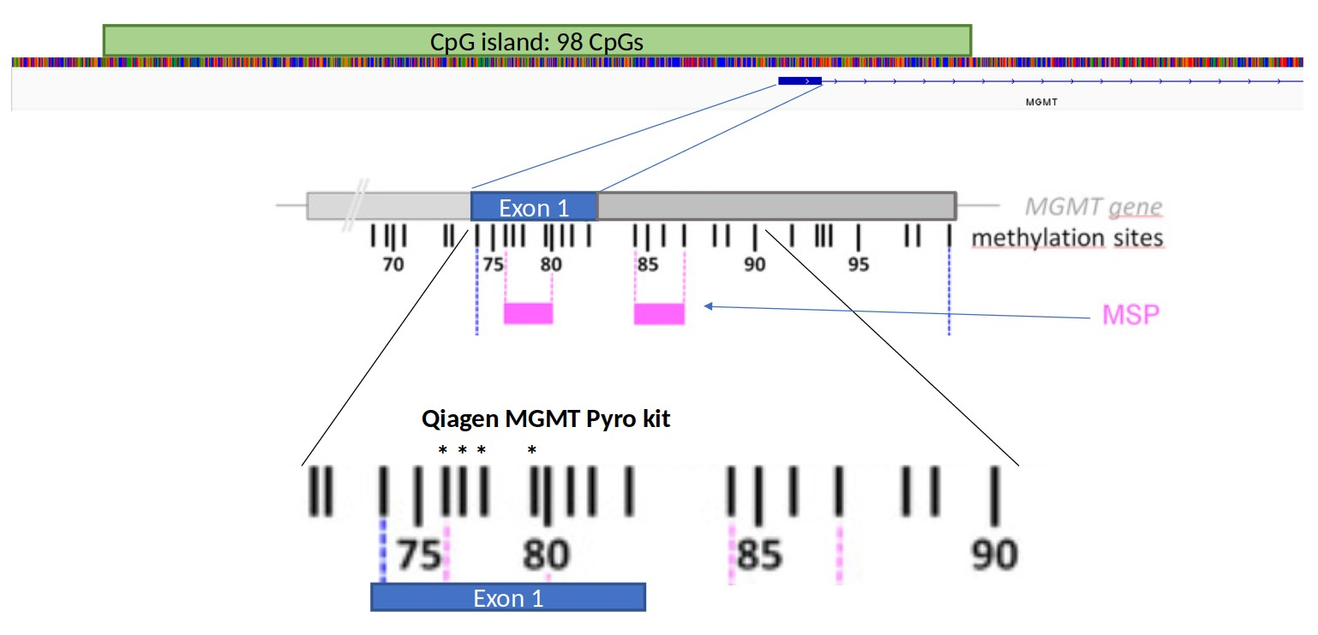

Figure 1: Organization of the *MGMT* promoter. MSP refers to the typical primer sites of methylation specific PCR to determine *MGMT* promoter methylation. Asterixes represent the 4 CpGs analysed by the Qiagen® MGMT pyrosequencing kit.

20

3

1

11

4

3

57

4

18

Other

Meningioma

IDH−glioma

Glioblastoma

0

25

50

75

Samples

Known Status

Methylated

UnMethylated

(a)

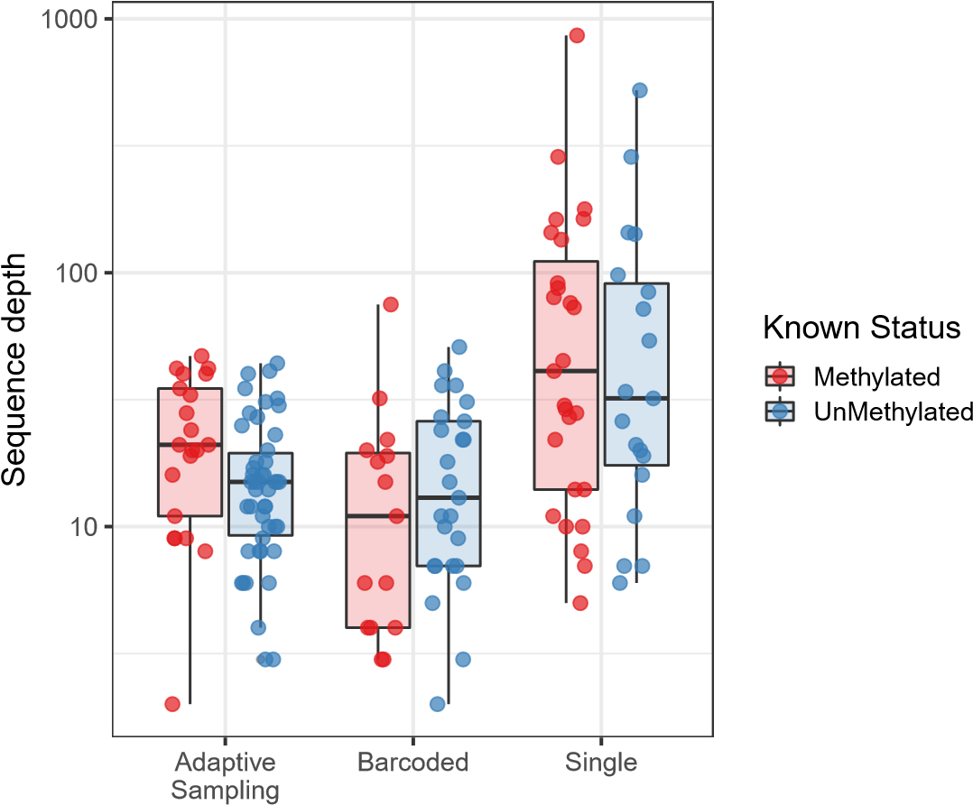

(b)

Figure 2: Overview of samples and sequence depth. (a) Classification of all samples used in this study, separated by known methylation status (b) Methylated versus unmethylated samples by method of acquisition (Adaptive sampling, multiplexed nCats, single sample nCats). No bias in sequence depth was observed between methylated and unmethylated samples but single sample runs generally have higher sequence depth than barcoded samples or adaptive sampling.

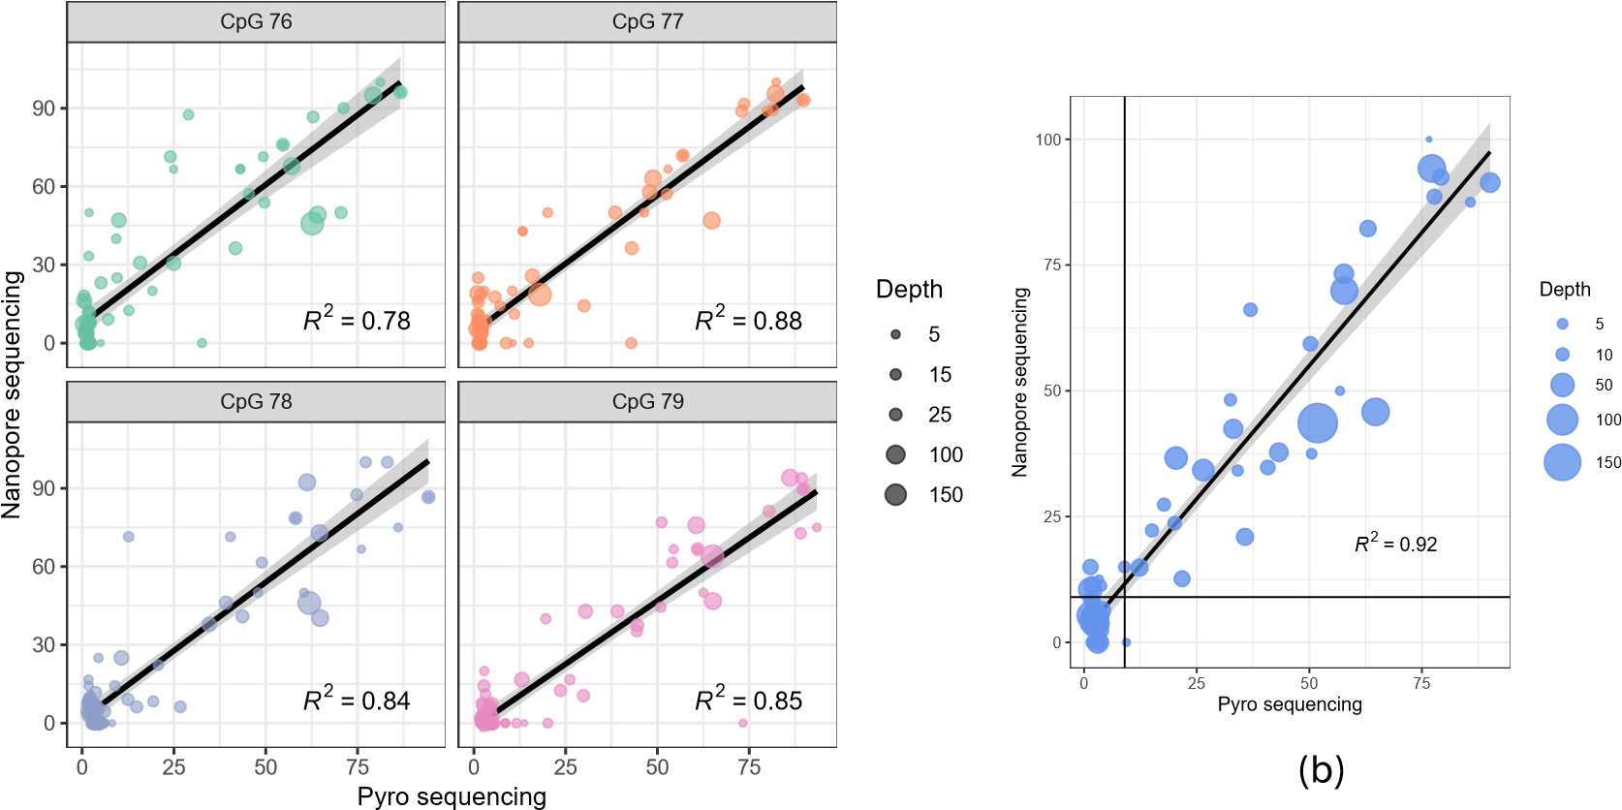

(a)

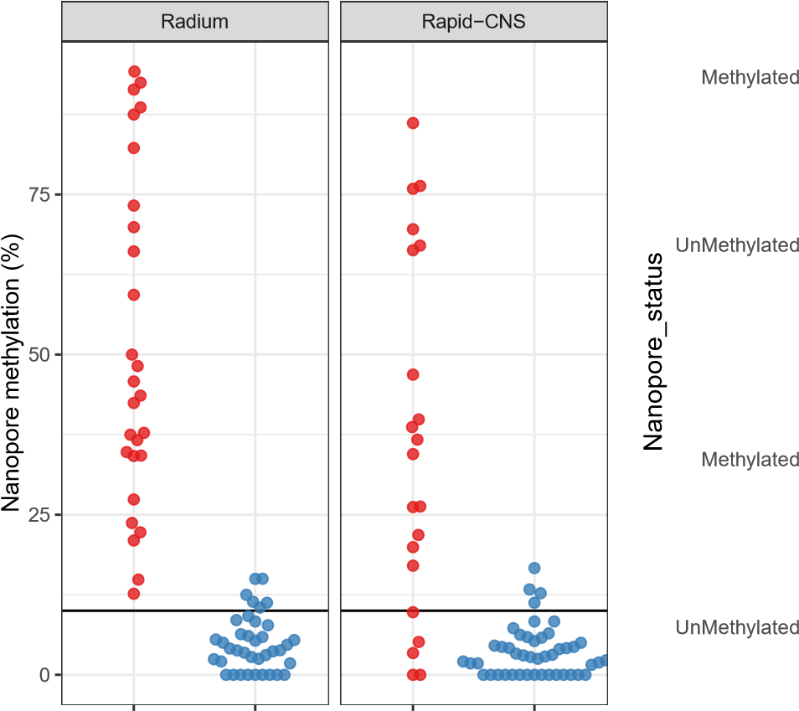 Methylated UnMethylated Methylated UnMethylated

32

0

6

3

0

4

2

5

4

16

Radium

Rapid−CNS

|  |  |
| --- | --- |
| Known methylation status (c) | UnMethylated Methylated Known_status |

(d)

Figure 3: Comparison of nanopore sequencing and Qiagen® Pyrosequencing kit of CpGs 76-79 in exon 1 of the *MGMT* promoter. Results show per-site methylation percentage of each CpG (a) or average values of the 4 CpG sites analyzed by the Qiagen® MGMT Pyro kit (b). Here, black horizontal and vertical lines mark the 10 % cut-off value between methylated and unmethylated samples, as determined by pyrosequencing. Comparison of pyrosequencing classification into methylated (red) versus unmethylated (blue) based on a 10% average methylation threshold of CpGs 76-79 in the *MGMT* promoter (c). The Y-axis represents average methylation percentage of the same four CpG sites based on nanopore sequencing. There needs to be a description regarding (d)

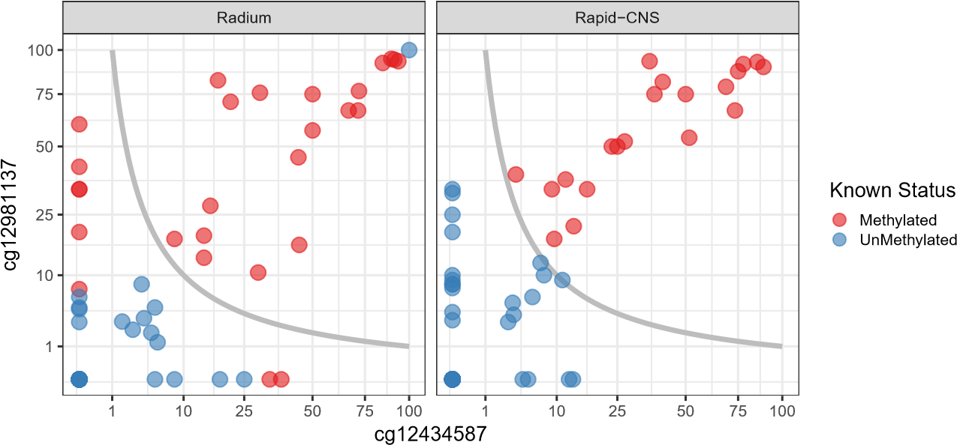

(a)

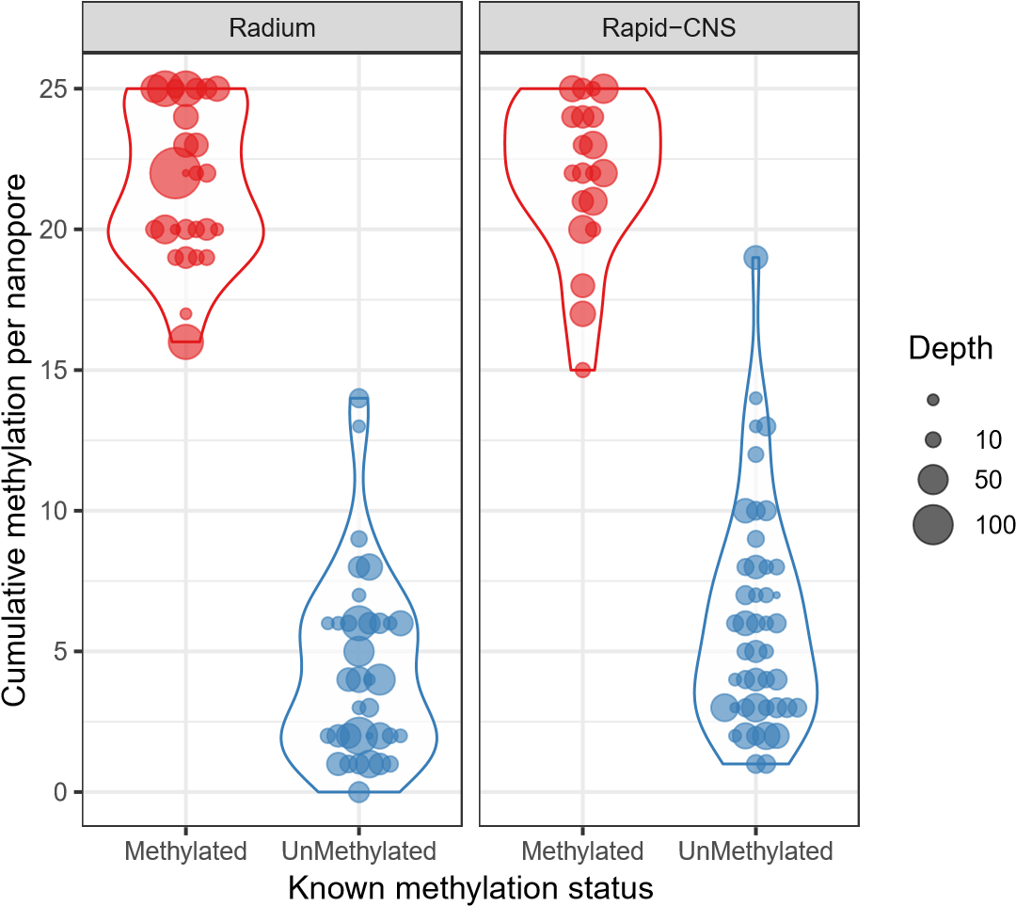5

(b)

Figure 4: Something about classifying tumor by an algorithm that only uses 2 CpGs (a). Something about how the different datasets classify differently (b). Something about classifying and sub-classifying tumors according to the methylation of the last 25 CpGs in the *MGMT* promoter region, as was proposed by Siller *et al.* [Siller et al., 2021] (c). The Y-axis represents aggregated methylation and CpGs 74 to 98 by Nanopore sequencing.

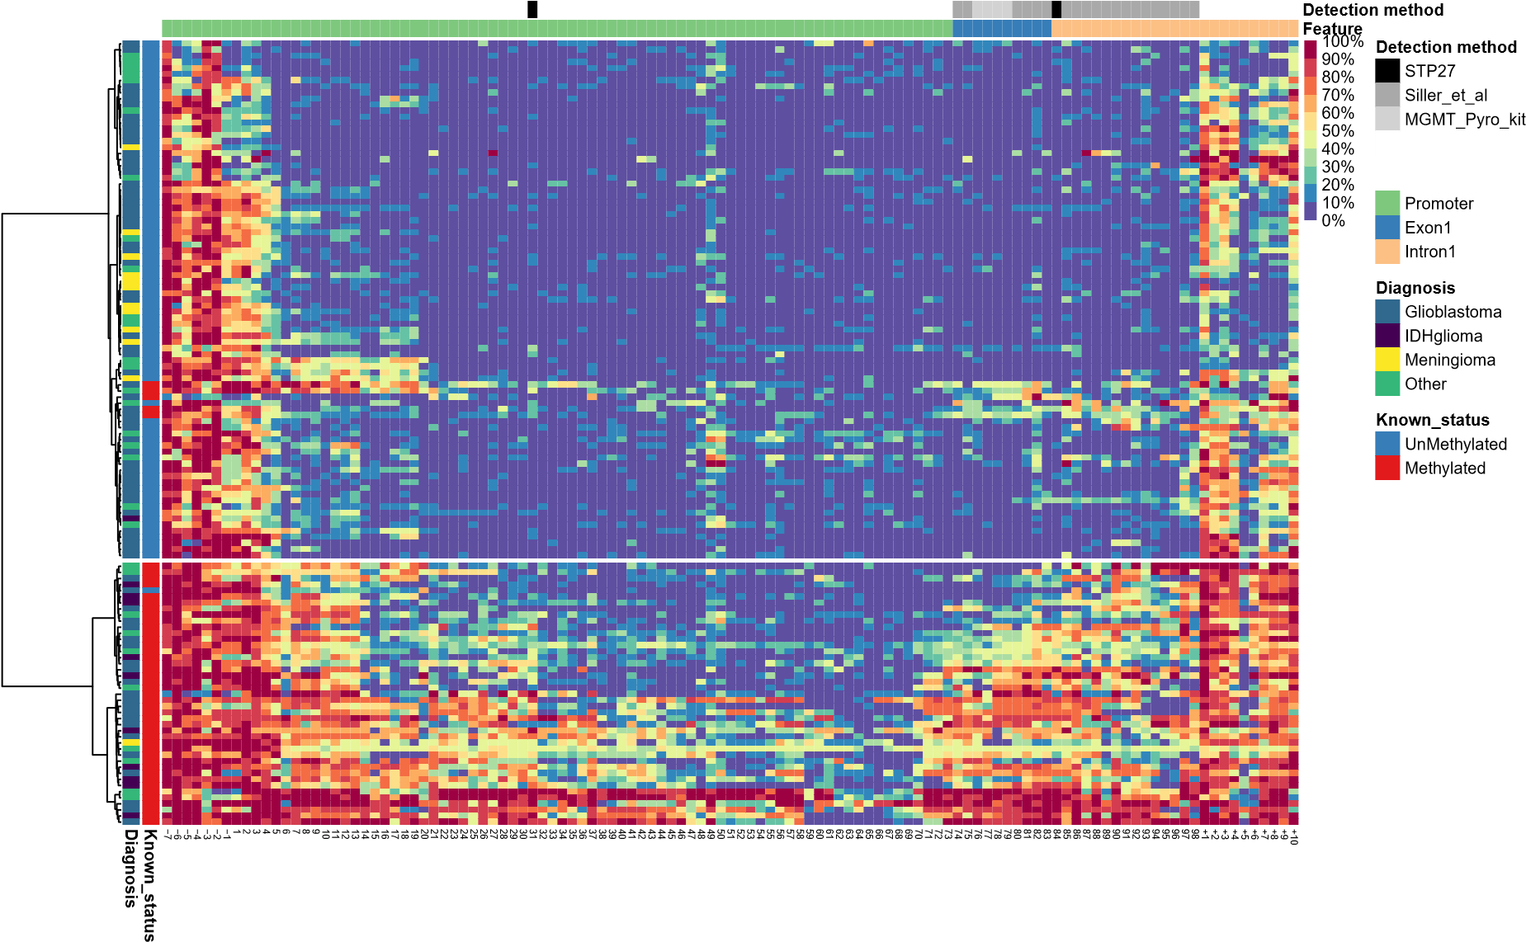

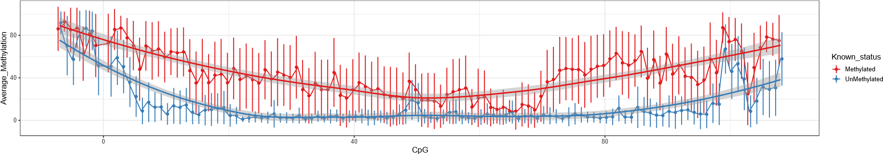

Figure 6: a) Dotplot showing average methylation percentage of CpG sites in and around the *MGMT* promoter. Grey areas show 95% confidence intervals of regression lines. n = 128. b) dotplot showing p-values of Welchs’ t-test between methylated and unmethylated samples at every CpG site.

**Feature**

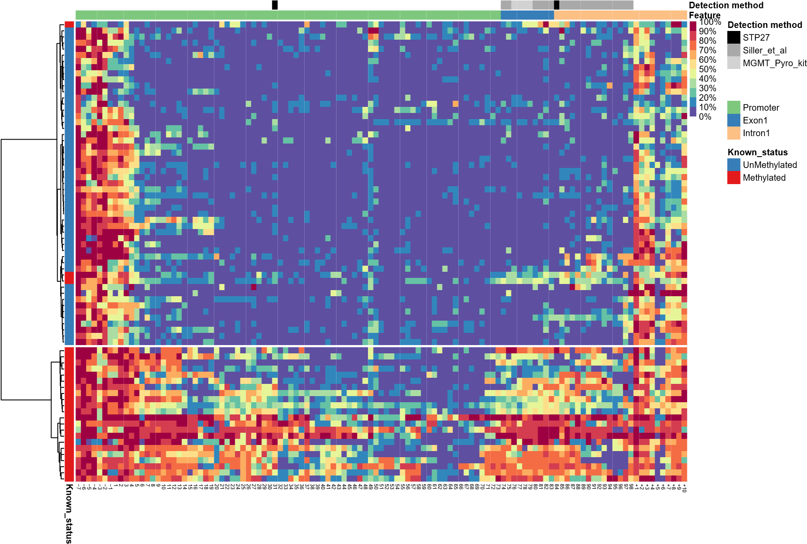Figure 7: Heatmap showing unsupervised clustering of glioblastoma samples based on nanopore sequencing of the CpG island in the *MGMT* promoter. n = 78

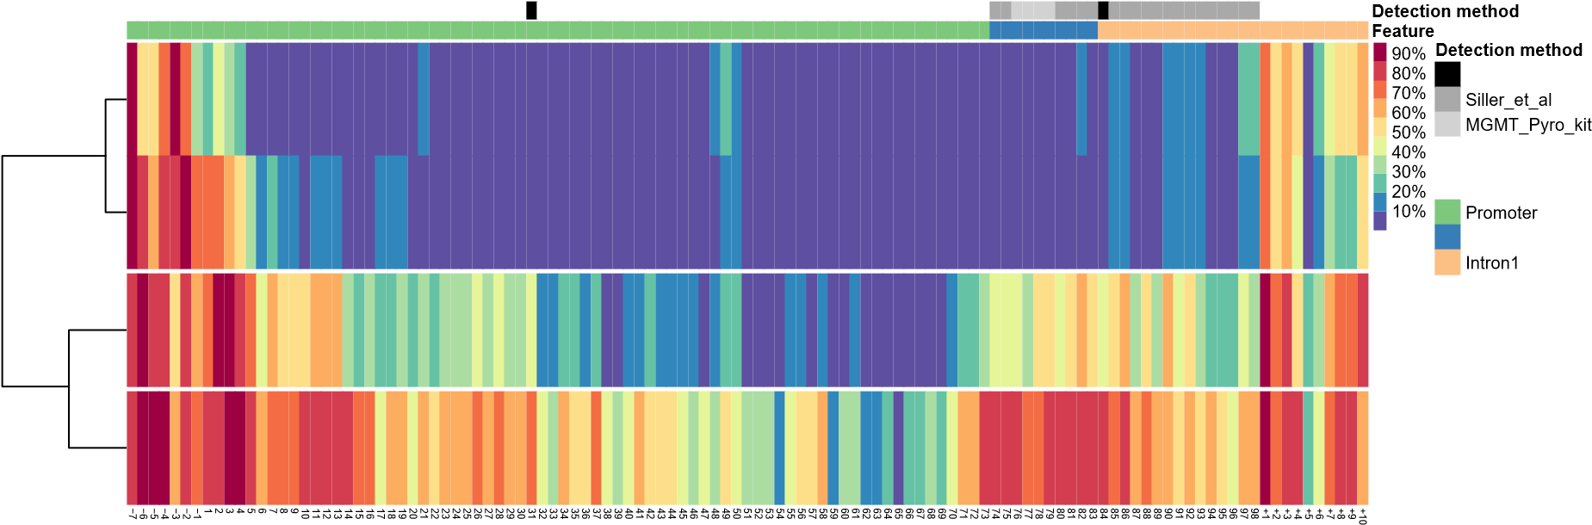STP27

**Feature** Exon1

Figure 8: K-means clustering of glioblastoma samples.

+

+

+

+

+

78

p = 0.00

0.00

0.25

0.50

0.75

1.00

0

10

20

30

**OS, Months**

**Survival probability**

Pyrosequencing

~~+~~

~~+~~

Methylated

UnMethylated

Number at risk

Pyrosequencing

18

1

6

9

9

4

0

7

5

2

1

0

0

10

Methylated

UnMethylated

5 15 20 25 30

OS, Months (a) Pyro classification

+

+

+

+

+

p = 0.0039

0.00

0.25

0.50

0.75

1.00

0

10

20

30

**OS, Months**

**Survival probability**

Nanopore

~~+~~

~~+~~

Cluster 1

Cluster 2

Number at risk

Nanopore

9

6

1

1

0

0

16

15

10

9

4

0

10

15

Cluster1

Cluster2

5 20 25 30

OS, Months

(b) Nano Classification

Figure 9: Patient survival based on Pyrosequencing classification (a) or Nanopore Sequencing classification (b) Kaplan Meier curves. These allow Mann Whitney test (is it the p value you were mentioning?e

G., Tran, D. D., Brem, S., Hottinger, A. F., Kirson, E. D., Lavy-Shahaf, G., Weinberg, U., Kim,

1. Y., Paek, S. H., Nicholas, G., Burna, J., Hirte, H., Weller, M., Palti, Y., Hegi, M. E., and Ram,Z. (2017). Effect of tumor-treating fields plus maintenance temozolomide vs maintenance temozolomide alone on survival in patients with glioblastoma a randomized clinical trial. *JAMA - Journal of the American Medical Association*, 318(23).

[Wongsurawat et al., 2020] Wongsurawat, T., Jenjaroenpun, P., De Loose, A., Alkam, D., Ussery,

1. W., Nookaew, I., Leung, Y. K., Ho, S. M., Day, J. D., and Rodriguez, A. (2020). A novel Cas9-targeted long-read assay for simultaneous detection of IDH1/2 mutations and clinically relevant MGMT methylation in fresh biopsies of diffuse glioma. *Acta Neuropathologica Communications*, 8(1):1–13.

[Xie et al., 2015] Xie, H., Tubbs, R., and Yang, B. (2015). Detection of MGMT promoter methylation in glioblastoma using pyrosequencing. *International Journal of Clinical and Experimental Pathology*, 8(2).

[Yuan et al., 2017] Yuan, G., Niu, L., Zhang, Y., Wang, X., Ma, K., Yin, H., Dai, J., Zhou, W., and Pan, Y. (2017). Defining optimal cutoff value of MGMT promoter methylation by ROC analysis for clinical setting in glioblastoma patients. *Journal of Neuro-Oncology*, 133(1).

[Zhang et al., 2011] Zhang, J., F.G. Stevens, M., and D. Bradshaw, T. (2011). Temozolomide:

Mechanisms of Action, Repair and Resistance. *Current Molecular Pharmacology*, 5(1).